**sudo curl -L https://github.com/docker/compose/releases/latest/download/docker-compose-$(uname -s)-$(uname -m) -o /usr/local/bin/docker-compose.**

Create the docker compose file by using **vi docker-compose.yaml** command**.**

Docker compose file

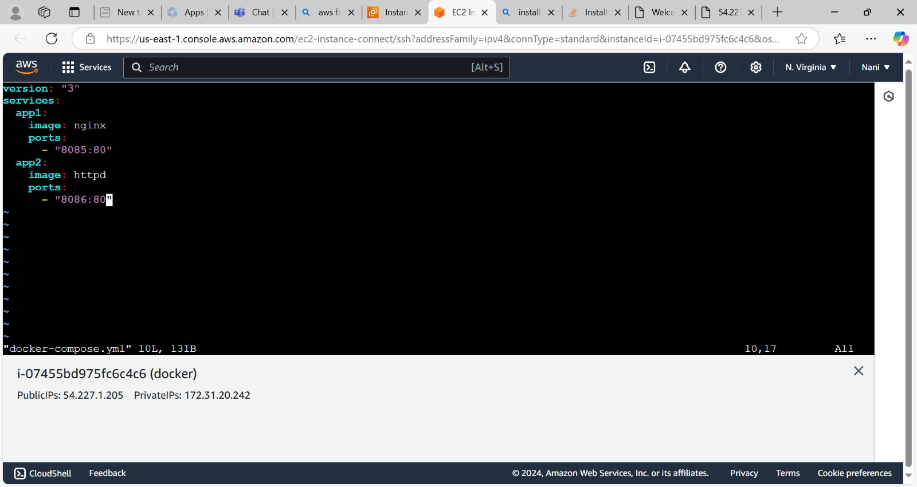

Execute or start the docker compose file by using **docker-compose up or docker-compose up -d** command.

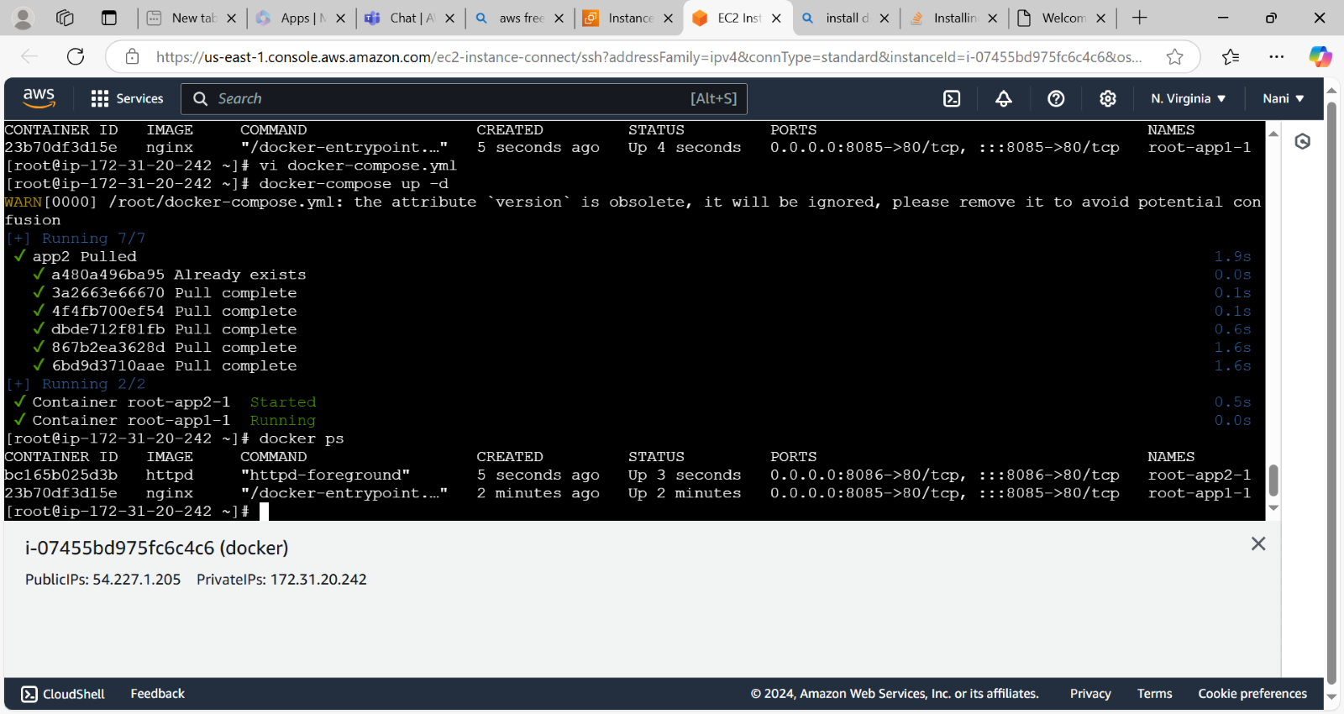

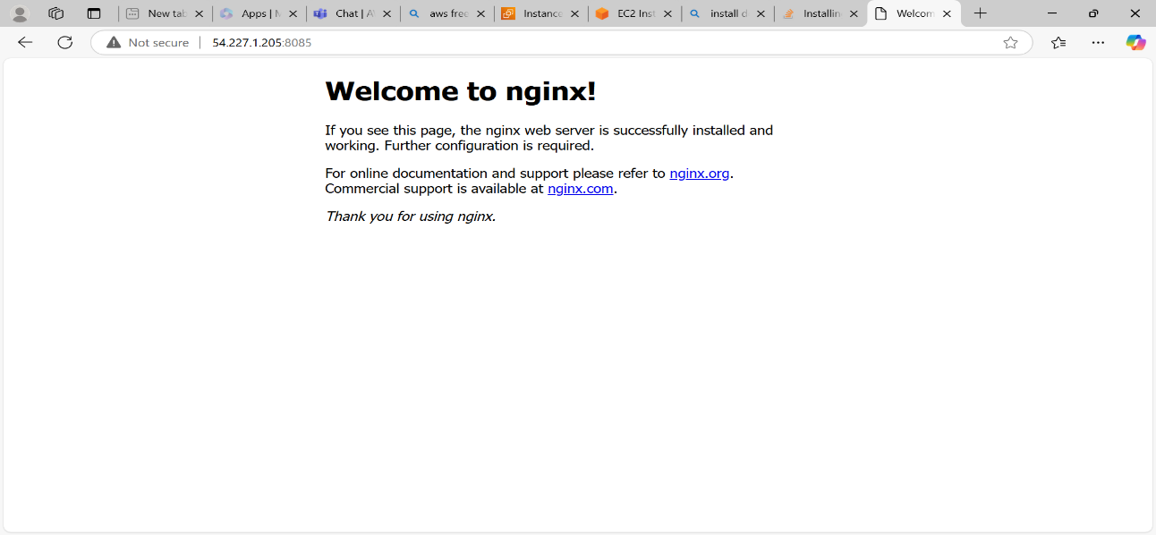

**docker-compose up -d**

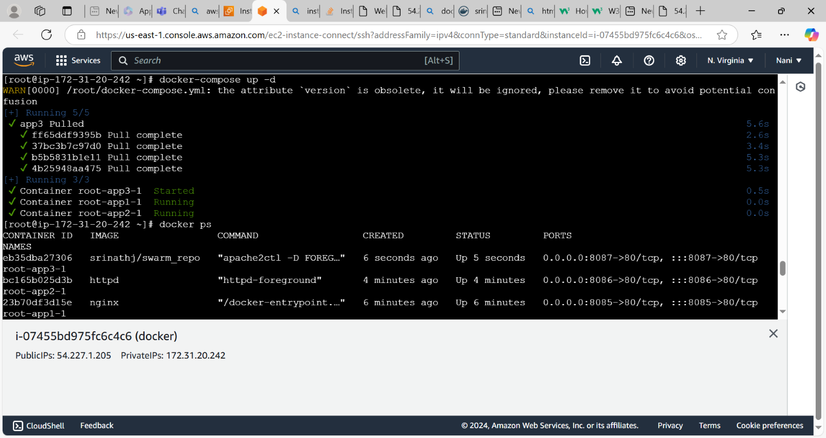

Access the application

